Assessment Tool Co2-Tool-1
Name: P. Manoj
Reg No:192411081
- The table below shows the annual premium increase rate (𝑥_{𝑖}) and the number of claims per 100 policyholders (𝑦_{𝑖}) in a health insurance company. Using the covariance formula, determine whether premium increase and claim frequency have a positive or inverse relationship. Before computing covariance, calculate the mean of 𝑥and 𝑦.
PREMIUM CLAIMS PER 100
INCREASE (%) POLICYHOLDERS ((Y_I))
((X_I))
3.2 | 15
4.0 | 18
5.5 | 25
4.8 | 20
Answer
Step 1: Calculate the Mean
Mean of Premium Increase:
3.2 + 4.0 + 5.5 + 4.8 17.5
𝑥̅ = = = 4.375
4 4

Mean of Claims:
15 + 18 + 25 + 20 78
𝑦̅ = = = 19.5
4 4
Step 2: Calculate Covariance Formula:
_{Cov}(𝑋, 𝑌) = ∑( 𝑥_{𝑖} − 𝑥̅)(𝑦_{𝑖} − 𝑦̅)
𝑛

Calculations:
    - (3.2 − 4.375) (15 − 19.5) = 5.2875
    - (4.0 − 4.375) (18 − 19.5) = 0.5625
    - (5.5 − 4.375) (25 − 19.5) = 6.1875
    - (4.8 − 4.375) (20 − 19.5) = 0.2125 Sum of products:
5.2875 + 0.5625 + 6.1875 + 0.2125 = 12.25

Covariance:
Cov(𝑋, 𝑌) = 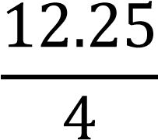 = 3.0625

Final Answer
    - Mean of Premium Increase (𝑥̅) = 4.375
    - Mean of Claims (𝑦̅) = 19.5
    - Covariance = 3.0625
Conclusion
Since the covariance is positive (3.0625), there is a positive relationship between premium increase and claim frequency. As the premium increase percentage rises, the number of claims per 100 policyholders also tends to increase.
- A hospital is analyzing patient blood pressure readings (systolic) to identify trends. Due to minor fluctuations, the analyst performs local smoothing using equalfrequency (equi-depth) binning.
Sample Data Set (Systolic BP Readings):
110, 112, 115, 115, 118, 120, 120, 122, 124, 124, 126, 126, 126, 126, 130, 135, 135, 138, 138, 138, 138, 140,
145, 150, 152, 160, 180 Answer:
Step 1: Number of Data Values
Total values = 27
Divide the data into 3 equal-frequency bins.
Number of values in each bin = 9
Step 2: Form the Bins Bin 1:
110, 112, 115, 115, 118, 120, 120, 122, 124 Bin 2:
124, 126, 126, 126, 126, 130, 135, 135, 138 Bin 3:
138, 138, 140, 145, 150, 152, 160, 180, 138
(After sorting Bin 3)
138, 138, 138, 140, 145, 150, 152, 160, 180
Step 3: Perform Local Smoothing (Replace each value with the Bin Mean)
Bin 1 Mean
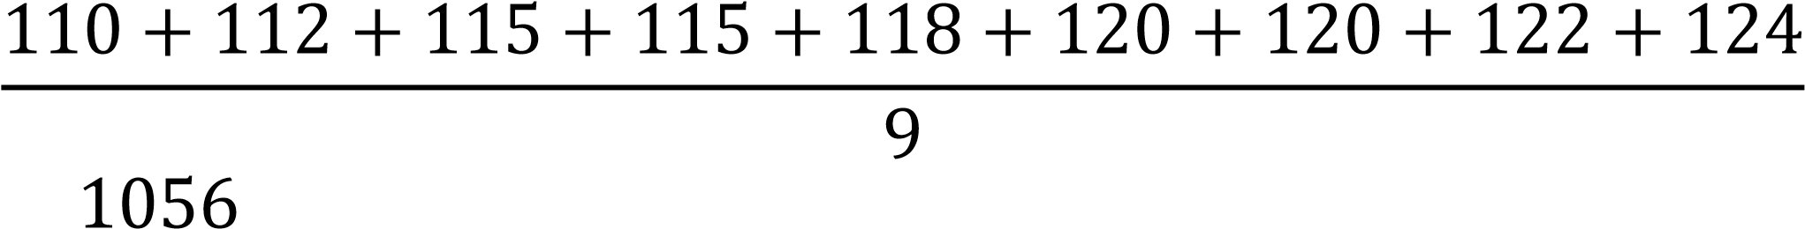
= = 117.33
9

Smoothed Bin 1:
117.33, 117.33, 117.33, 117.33, 117.33, 117.33, 117.33, 117.33, 117.33

Bin 2 Mean
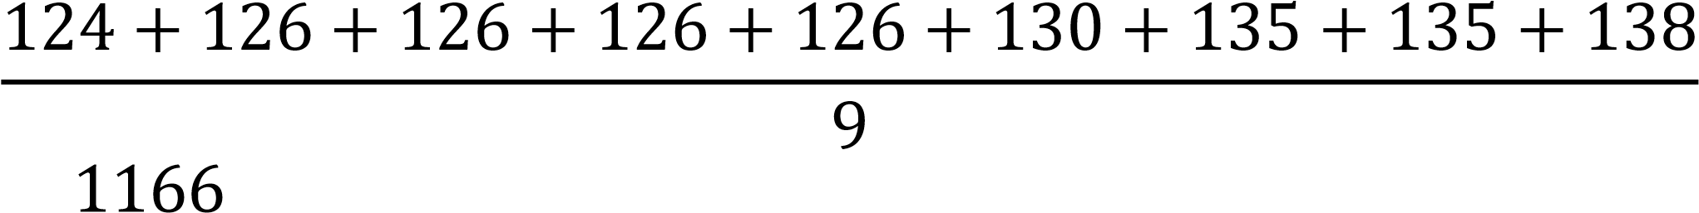
= = 129.56
9

Smoothed Bin 2:
129.56, 129.56, 129.56, 129.56, 129.56, 129.56, 129.56, 129.56, 129.56

Bin 3 Mean
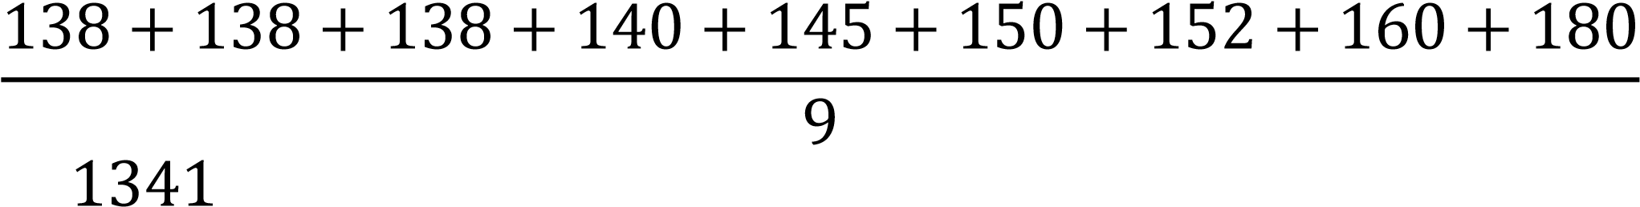
= = 149.00
9

Smoothed Bin 3:
149, 149, 149, 149, 149, 149, 149, 149, 149

Final Answer
Equal-Frequency Bins
- Bin 1: 110, 112, 115, 115, 118, 120, 120, 122, 124
- Bin 2: 124, 126, 126, 126, 126, 130, 135, 135, 138
- Bin 3: 138, 138, 138, 140, 145, 150, 152, 160, 180
Smoothed Data (Using Bin Mean)
- Bin 1 Mean = 117.33
- Bin 2 Mean = 129.56
- Bin 3 Mean = 149.00 Smoothed Dataset: 117.33, 117.33, 117.33, 117.33, 117.33, 117.33, 117.33, 117.33, 117.33,
129.56, 129.56, 129.56, 129.56, 129.56, 129.56, 129.56, 129.56, 129.56,
149.00, 149.00, 149.00, 149.00, 149.00, 149.00, 149.00, 149.00, 149.00
3. An insurance company evaluates Body Mass Index (BMI) of 18 clients for risk classification. To simplify analysis, they smooth the data by replacing values with the closest bin boundaries using equal-width partitioning.
Sample Data Set (Sorted BMI):
18.5, 19.2, 21.8, 24.9, 25.5, 26.2, 26.4, 27.8, 29.2, 30.2,
30.4, 31.9, 32.4, 33.1, 33.6, 34.7, 38.2, 39.5 Answer:
Step 1: Calculate the Bin Width
Minimum value = 18.5 Maximum value = 39.5 Range:
39.5 − 18.5 = 21

Assume 3 equal-width bins.
Bin Width:
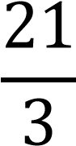 = 7

Step 2: Form the Equal-Width Bins
  - Bin 1: 18.5 – 25.5
  - Bin 2: 25.5 – 32.5
  - Bin 3: 32.5 – 39.5
Step 3: Replace Each Value with the Closest Bin
Boundary Bin 1 (18.5–25.5) Original Values:
18.5, 19.2, 21.8, 24.9, 25.5 Smoothed Values:
18.5, 18.5, 18.5, 25.5, 25.5

Bin 2 (25.5–32.5) Original Values:
26.2, 26.4, 27.8, 29.2, 30.2, 30.4, 31.9, 32.4 Smoothed Values:
25.5, 25.5, 25.5, 25.5, 32.5, 32.5, 32.5, 32.5

Bin 3 (32.5–39.5)
Original Values:
33.1, 33.6, 34.7, 38.2, 39.5 Smoothed Values:
32.5, 32.5, 32.5, 39.5, 39.5

Final Answer
Equal-Width Bins
- Bin 1: 18.5 – 25.5
- Bin 2: 25.5 – 32.5
- Bin 3: 32.5 – 39.5
Smoothed Data (Nearest Bin Boundary)
18.5, 18.5, 18.5, 25.5, 25.5,
25.5, 25.5, 25.5, 25.5, 32.5, 32.5, 32.5, 32.5,
32.5, 32.5, 32.5, 39.5, 39.5
Conclusion
The BMI values are grouped into three equal-width bins, and each value is replaced with its nearest bin boundary, reducing minor variations and making the data easier to analyse for risk classification.
4. A hospital administration is reviewing the cost of medical consumables (in ₹). To reduce data for mining purposes, they discretize the sorted price records using bin medians.
Sample Data Set (Costs in ₹):
120, 140, 145, 145, 148, 150, 150, 150, 155, 155, 155,
155, 160, 160, 165, 170, 170, 175, 175, 175, 175, 180,
190, 200, 210, 230, 300 Answer:
Step 1: Number of Data Values
Total values = 27
Divide the data into 3 equal-frequency bins.
Number of values in each bin = 9
Step 2: Form the Bins Bin 1:
120, 140, 145, 145, 148, 150, 150, 150, 155 Bin 2:
155, 155, 155, 160, 160, 165, 170, 170, 175 Bin 3:
175, 175, 175, 180, 190, 200, 210, 230, 300
Step 3: Find the Median of Each Bin
Bin 1 Median
Middle (5th) value = 148
Bin 2 Median
Middle (5th) value = 160
Bin 3 Median
Middle (5th) value = 190
Step 4: Replace Each Value with the Bin Median Bin 1:
148, 148, 148, 148, 148, 148, 148, 148, 148 Bin 2:
160, 160, 160, 160, 160, 160, 160, 160, 160 Bin 3:
190, 190, 190, 190, 190, 190, 190, 190, 190

Final Answer
Equal-Frequency Bins
- Bin 1: 120, 140, 145, 145, 148, 150, 150, 150, 155
- Bin 2: 155, 155, 155, 160, 160, 165, 170, 170, 175
- Bin 3: 175, 175, 175, 180, 190, 200, 210, 230, 300
Bin Medians
- Bin 1 Median = ₹148
- Bin 2 Median = ₹160
- Bin 3 Median = ₹190
Smoothed Data (Using Bin Medians)
148, 148, 148, 148, 148, 148, 148, 148, 148,
160, 160, 160, 160, 160, 160, 160, 160, 160,
190, 190, 190, 190, 190, 190, 190, 190, 190
Conclusion
The medical supply costs are divided into three equalfrequency bins, and each value is replaced by the median of its bin, reducing data variation while preserving the central value of each group.
5. Given the following ages of insured individuals:
18, 22, 25, 42, 28, 43, 33, 35, 56, 28
Standardize the variable by performing the following:
- Compute the Mean Absolute Deviation (MAD) of age.
- Compute the z-score for the first four observations.
Answer:
Step 1: Calculate the Mean
Mean
= 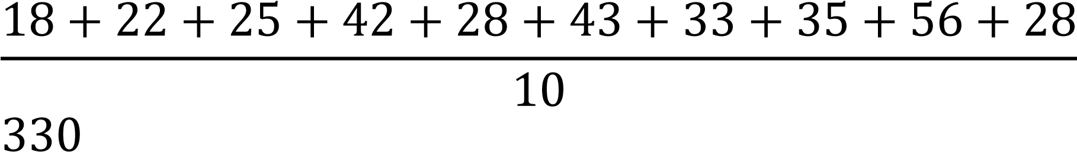
= = 33
10

- Mean Absolute Deviation (MAD) Formula:
∑ ∣ 𝑥 − 𝑥̅ ∣
MAD =
𝑛

Absolute deviations from the mean (33):
  - |18 − 33| = 15
  - |22 − 33| = 11
  - |25 − 33| = 8
  - |42 − 33| = 9
  - |28 − 33| = 5
  - |43 − 33| = 10
  - |33 − 33| = 0
  - |35 − 33| = 2
  - |56 − 33| = 23
  - |28 − 33| = 5
Sum of absolute deviations:
15 + 11 + 8 + 9 + 5 + 10 + 0 + 2 + 23 + 5 = 88

Mean Absolute Deviation:
MAD = 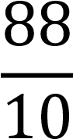 = 8.8

Answer (a):
MAD = 8.8

- Compute the z-score for the First Four
Observations
Formula:
𝑥 − 𝑥̅
𝑧 =
𝜎

Population Standard Deviation:
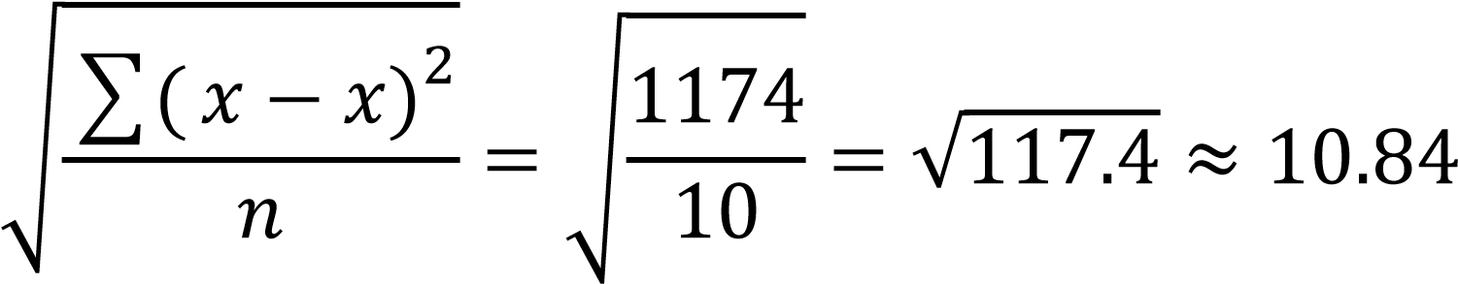
̅
𝜎 =

Now calculate the z-scores:
  - For 18:
𝑧 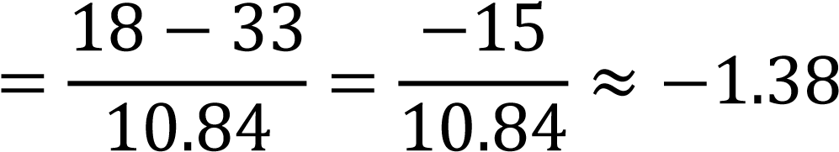

  - For 22:
𝑧 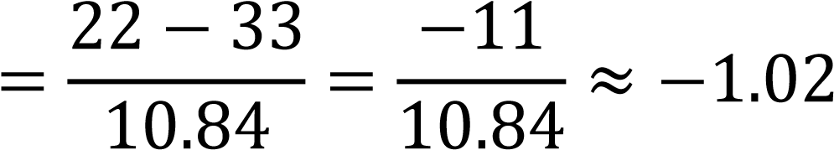

  - For 25:
𝑧 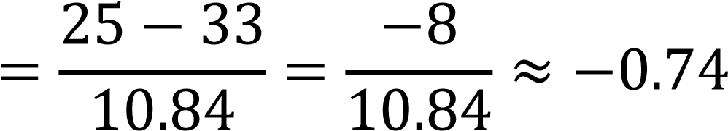

  - For 42:
𝑧 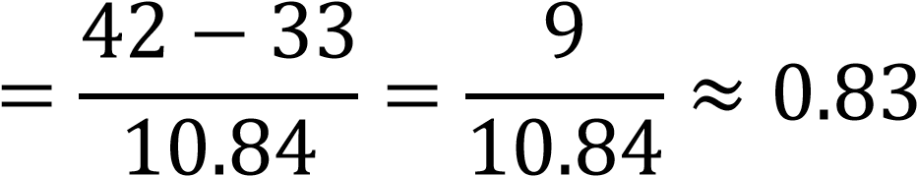
Final Answer
  - Mean = 33
  - Mean Absolute Deviation (MAD) = 8.8
  - Standard Deviation ≈ 10.84
Z-Scores (First Four Observations)
Age | Z-Score
18 | −1.38
22 | −1.02
25 | −0.74
42 | 0.83

